WEEK 1 TASK
DATA ACQUISITION, CLEANING & EXPLORATORY ANALYSIS
Air Quality Analysis using the UCI Air Quality Dataset
Prepared using Python, Pandas, NumPy and Matplotlib

1. Introduction
This project demonstrates a complete data preparation and exploratory data analysis workflow using the UCI Air Quality dataset. The dataset contains hourly measurements collected from an air-quality monitoring station in an Italian city during 2004–2005. It includes pollutant concentrations measured by reference analysers and sensor responses, together with temperature, relative humidity and absolute humidity. The objective of this analysis is to acquire the data, identify and correct data-quality issues, transform the variables into analysis-ready form, and use descriptive statistics and visualizations to identify meaningful patterns.
The dataset is particularly suitable for this task because it contains a realistic data-cleaning challenge: missing measurements are represented by the sentinel value -200 rather than standard blank or NA values. The analysis therefore illustrates an important practical data-science skill—recognizing domain-specific missing-value encodings before calculating statistics or creating plots.

2. Dataset Acquisition
The analysis used the publicly available UCI Air Quality dataset. The downloaded CSV contains 9,357 hourly observations and 13 measurement variables. The UCI documentation reports 9,358 instances and 15 attributes, with missing values encoded as -200. The dataset is distributed under a Creative Commons Attribution 4.0 International license.
Source: UCI Machine Learning Repository, Air Quality dataset (Vito, 2008).
The working CSV was read with Pandas using a semicolon delimiter because the original file is semicolon-separated.

3. Data Cleaning and Preprocessing

3.1 Initial inspection
The raw file contained 9,357 observations. The Date and Time fields were combined into a single DateTime index and parsed using day-first date interpretation. All measurement columns were explicitly converted to numeric values so that statistical calculations and visualizations would behave correctly.

3.2 Missing-value treatment
A total of 16,701 cells (13.73% of all measurement cells) were encoded as -200. Because -200 is outside the valid physical range of the measured quantities and is explicitly defined by the dataset documentation as a missing-value marker, these values were replaced with NaN.
Variable | Missing (-200) | Percentage
NMHC(GT) | 8,443 | 90.2%
CO(GT) | 1,683 | 18.0%
NO2(GT) | 1,642 | 17.5%
NOx(GT) | 1,639 | 17.5%
PT08.S1(CO) | 366 | 3.9%
For the time-indexed measurements, missing observations were filled using time-based linear interpolation. This approach was selected because the observations are hourly and adjacent measurements generally represent the same continuous environmental process. Any remaining missing values were filled with the corresponding column median as a final fallback.

3.3 Duplicate records
After missing-value conversion, 31 exact duplicate rows were identified and removed. Removing exact duplicates prevents repeated observations from disproportionately influencing summary statistics.

4. Exploratory Data Analysis
Descriptive statistics were calculated after cleaning. The distributions were examined using histograms, time-of-day patterns were explored using grouped means, relationships between pollutants were assessed with scatter plots and correlations, and monthly patterns were examined to identify broad seasonal variation.

4.1 Distribution of CO
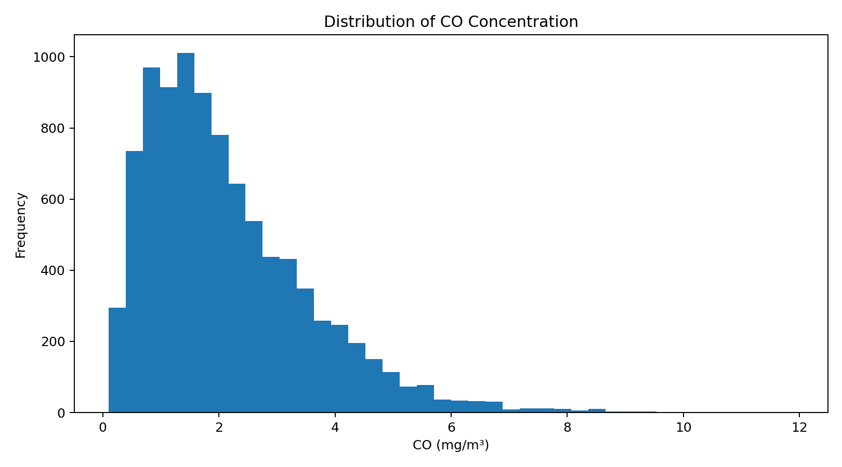
The CO distribution is positively skewed: most observations occur at relatively low concentrations, while a smaller number of observations show substantially higher pollution levels. This indicates that the mean alone may not fully represent a typical observation and that extreme pollution episodes deserve separate attention.

4.2 Pollution levels across the day
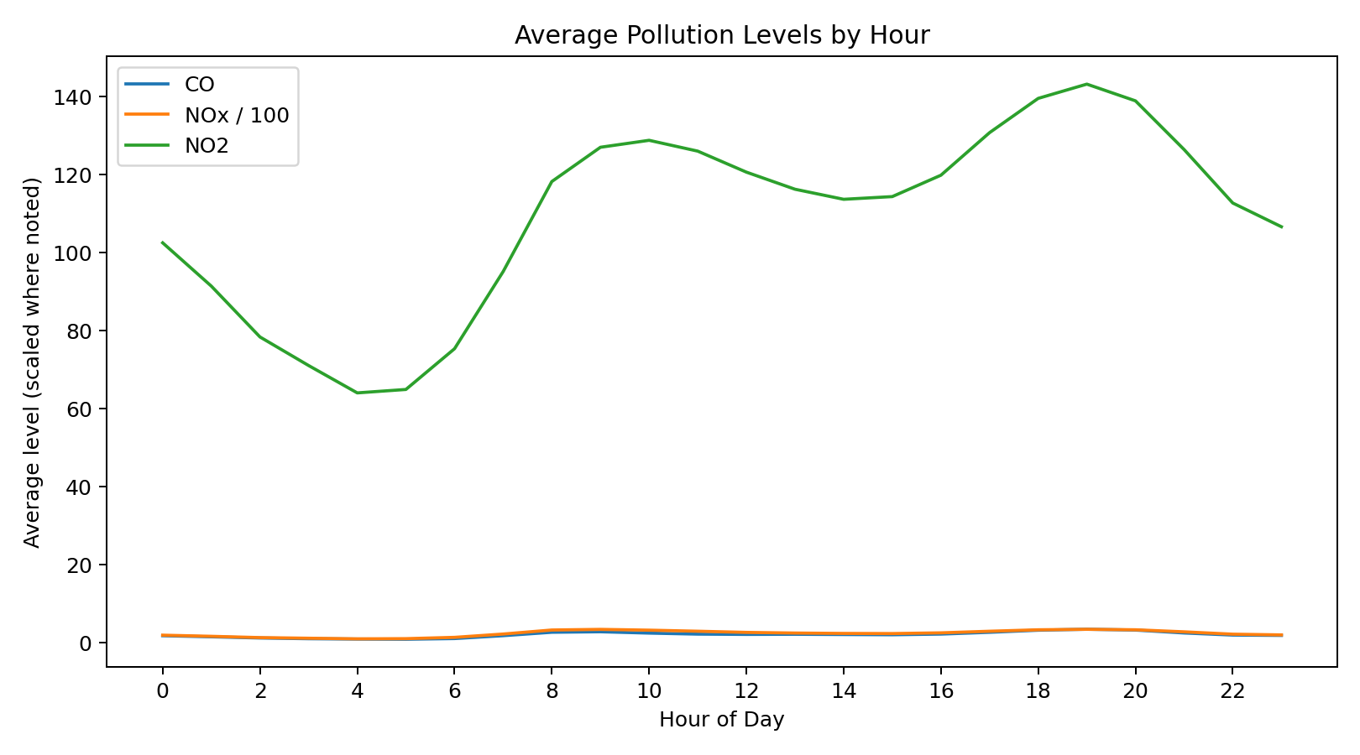
Pollution levels vary systematically throughout the day. The hourly profiles show higher concentrations during parts of the morning and evening compared with several daytime hours. Such patterns are consistent with changes in human activity, traffic intensity and atmospheric mixing, although this observational analysis does not establish causality.

4.3 Relationship between CO and NOx
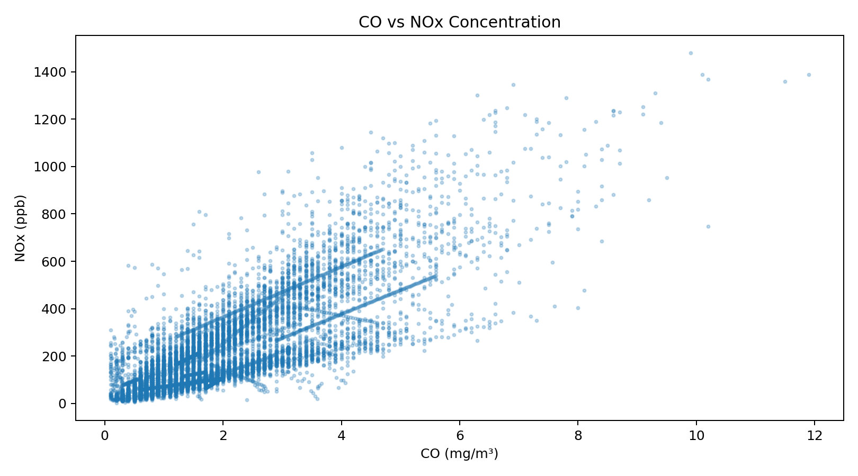
The scatter plot shows a clear positive association between CO and NOx concentrations (Pearson correlation approximately 0.79). Higher CO measurements are generally accompanied by higher NOx measurements, suggesting that these pollutants can rise together under similar pollution conditions.

4.4 Correlation analysis
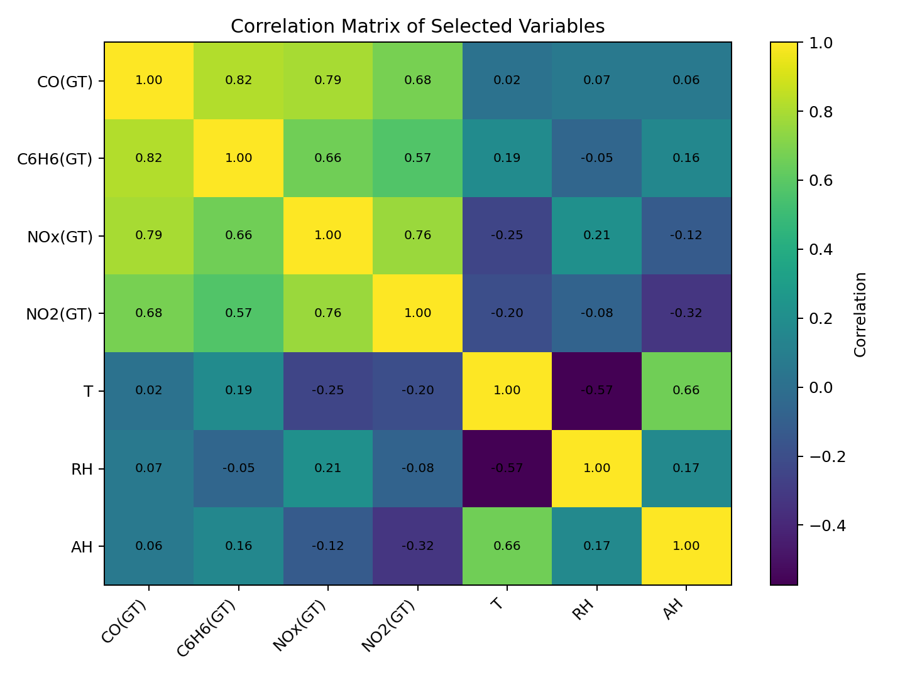
The correlation matrix highlights strong relationships among several pollutant variables. For example, CO has a correlation of 0.79 with NOx. Strong associations between pollutant measurements and sensor-response variables also indicate that the measured variables are not independent. This is useful information for any future predictive modelling because multicollinearity may need to be considered.

4.5 Monthly variation
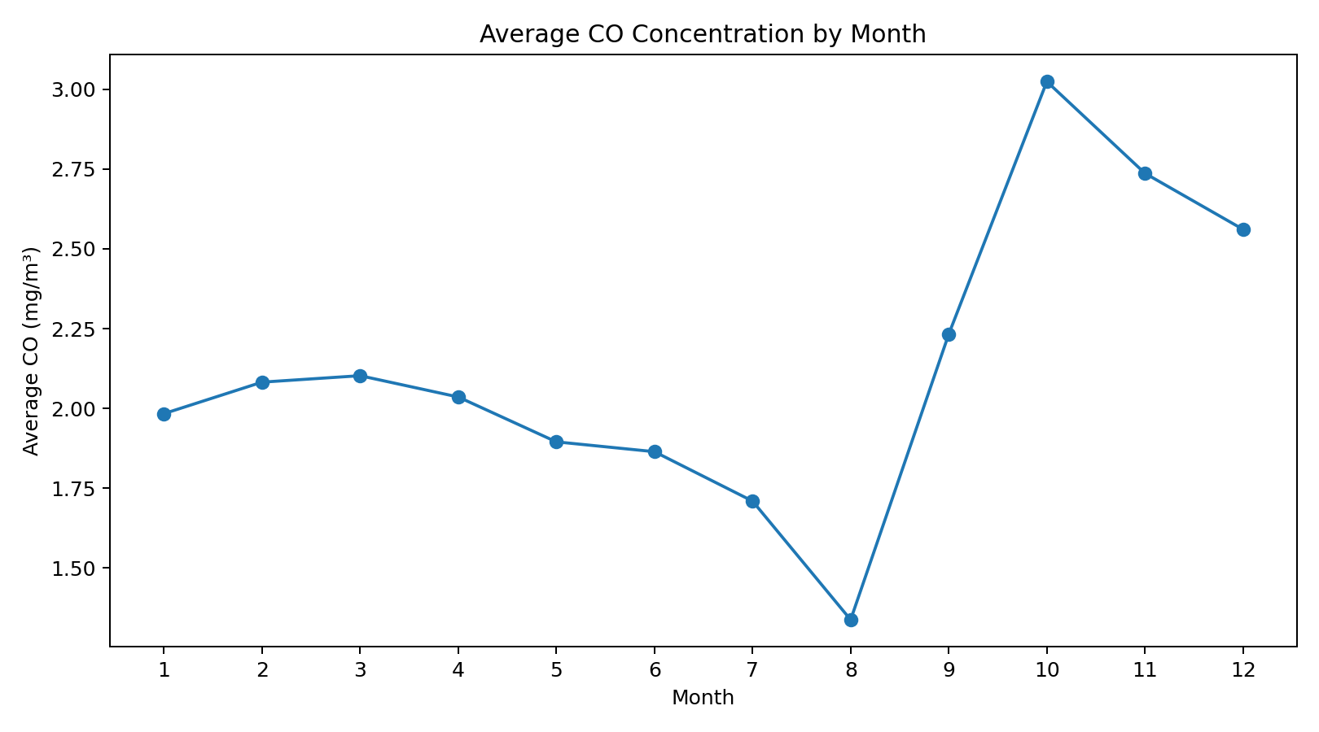
The monthly averages demonstrate that pollution levels vary over the observation period. Because the dataset covers a limited historical period rather than many repeated years, these differences should be interpreted as observed temporal variation rather than definitive long-term seasonal trends.

5. Key Insights
- The dataset contains a substantial amount of missing information represented by the non-standard sentinel value -200; detecting this encoding was a critical cleaning step.
- CO concentrations are right-skewed, indicating occasional high-pollution episodes that can influence averages.
- CO and NOx show a positive linear association (r ≈ 0.79), indicating that elevated levels of these pollutants tend to occur together.
- Pollution varies across the 24-hour cycle, with identifiable high- and low-concentration periods.
- Several pollutant variables are strongly correlated, suggesting shared sources or atmospheric processes and potential multicollinearity in future machine-learning models.
- Time interpolation is appropriate for many hourly sensor gaps because adjacent measurements provide information about the underlying continuous process, while median filling provides a conservative fallback.

6. Limitations and Further Analysis
The analysis is observational and does not prove causal relationships between weather, human activity and pollution. The monitoring station represents a specific location, so the findings should not automatically be generalized to other cities. Future work could include time-series forecasting, pollutant prediction, anomaly detection, clustering of pollution episodes, and statistical testing of differences between hours or seasons.

7. Code Snippets
import pandas as pd
import numpy as np
df = pd.read_csv("AirQualityUCI.csv", sep=";")
df["DateTime"] = pd.to_datetime(
df["Date"] + " " + df["Time"], dayfirst=True
)
df = df.drop(columns=["Date", "Time"]).set_index("DateTime")
for col in df.columns:
df[col] = pd.to_numeric(df[col], errors="coerce")
# Dataset-specific missing-value marker
df = df.replace(-200, np.nan)
# Remove exact duplicate observations
df = df.drop_duplicates()
# Time-based interpolation
df = df.interpolate(method="time", limit_direction="both")
# Median fallback
for col in df.columns:
df[col] = df[col].fillna(df[col].median())
# Example EDA
df["Hour"] = df.index.hour
hourly = df.groupby("Hour")[["CO(GT)", "NOx(GT)", "NO2(GT)"]].mean()
print(df.describe())
print(df.corr(numeric_only=True)["CO(GT)"].sort_values())

8. Conclusion
This project completed the required data acquisition, cleaning, preprocessing and exploratory analysis workflow. The final dataset is structured as a time-indexed numerical dataset suitable for further statistical or machine-learning work. The EDA revealed meaningful temporal variation, skewed pollutant distributions and strong relationships among pollutants. Most importantly, the project demonstrates that reliable analysis begins with careful data-quality checks and domain-aware preprocessing rather than immediately creating models or visualizations.

References
Vito, S. (2008). Air Quality [Dataset]. UCI Machine Learning Repository. DOI: 10.24432/C59K5F.
UCI Machine Learning Repository. Air Quality dataset documentation and variable descriptions.

